**DAILY ONLINE ACTIVITIES SUMMARY**

|  |  |  |  |  |  |  |  |  |
| --- | --- | --- | --- | --- | --- | --- | --- | --- |
| **Date:** | **10-06-2020** | | | | | **Name:** | **Kavya** | |
| **Sem & Sec** | **6th & A** | | | | | **USN:** | **4al17cs041** | |
| **Online Test Summary** | | | | | | | | |
| **Subject** | | **SSCD** | | | | | | |
| **Max. Marks** | | **30** | | **Score** | | | **27** | |
| **Certification Course Summary** | | | | | | | | |
| **Course** | **Socket Programming In Python** | | | | | | | |
| **Certificate Provider** | | | **Udemy** | | **Duration** | | | **2.5 Hours** |
| **Coding Challenges** | | | | | | | | |
| **Problem Statement:1.** Write a C Program to print the sum of boundary elements of a matrix | | | | | | | | |
| **Status:Yes, I have uploaded all the programs.** | | | | | | | | |
| **Uploaded the report in Github** | | | | | **Yes** | | | |
| **If yes Repository name** | | | | | [**https://github.com/kavya-077/DAILY-STATUS**](https://github.com/kavya-077/DAILY-STATUS) | | | |
| **Uploaded the report in slack** | | | | | **Yes** | | | |

Online Test Details: (Attach the snapshot and briefly write the report for the same)

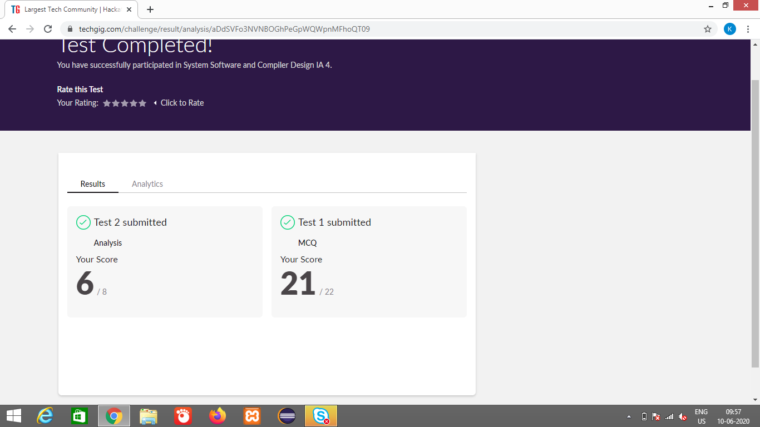

Certification Course Details: (Attach the snapshot and briefly write the report for the same)

SOCKET PROGRAMMING IN PYTHON

**What we’ll learn**

* Learn to Use Sockets in Python
* Basics of Networking
* Basics of Sockets | What is a Socket?
* Write Socket Program using Python socket module
* TCP/IP Client and Server
* Build a Python Socket Client with Example
* UDP Client/Server Socket in Python with Example
* Make a Multithreaded Socket Server
* Socket Server with Multiple Clients

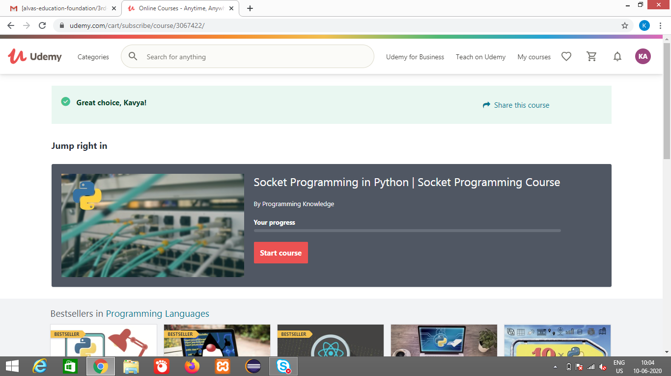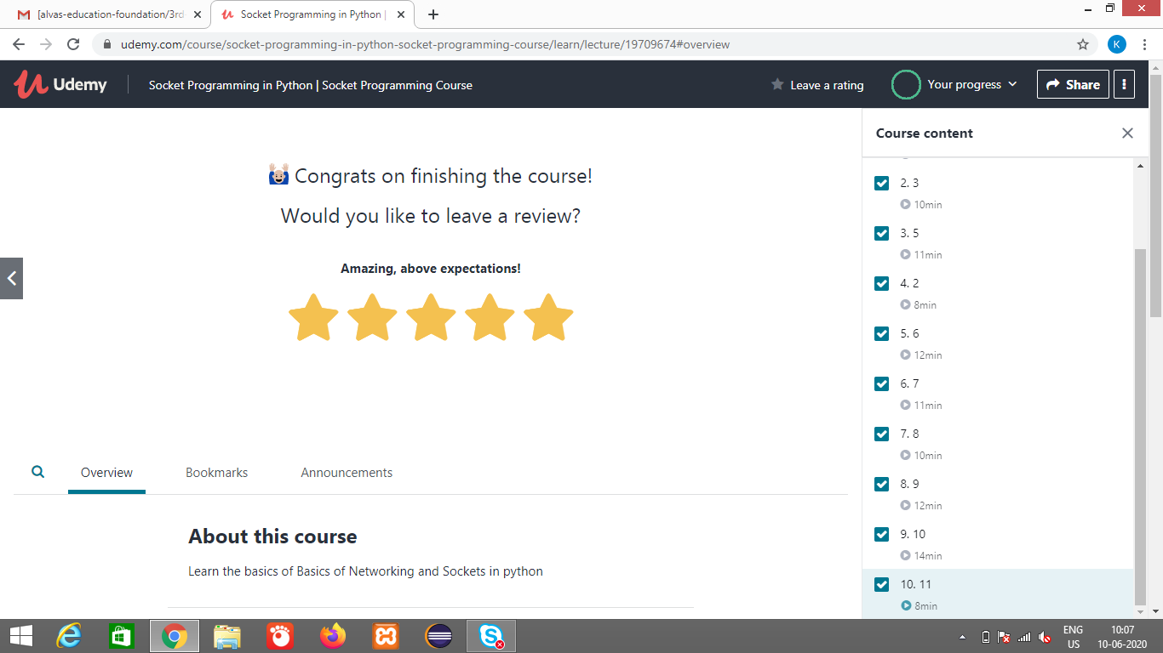

[**https://github.com/alvas-education-foundation/kavya-onlinecourse**](https://github.com/alvas-education-foundation/kavya-onlinecourse)

Coding Challenges Details: (Attach the snapshot and briefly write the report for the same)

[**https://github.com/alvas-education-foundation/kavya-OCA**](https://github.com/alvas-education-foundation/kavya-OCA)